INHERITANCE:

Inheritance in Object-Oriented Programming (OOP) is a mechanism where a new class (called a "subclass" or "derived class") is based on an existing class (called a "superclass" or "base class"). This allows the subclass to inherit attributes and methods from the superclass.

Types of inheritance in oops :

Single Inheritance

Multilevel Inheritance

Hierarchical Inheritance

Multiple Inheritance (Through Interfaces)

Hybrid Inheritance

EXAMPLES:

Single Inheritance:

package JAVA_CONCEPTS;

import java.util.Scanner;

class ApplicationForm {

protected String name;

protected String email;

protected String phone;

public ApplicationForm(String name, String email, String phone) {

this.name = name;

this.email = email;

this.phone = phone;

}

public String getName() {

return name;

}

public String getEmail() {

return email;

}

public String getPhone() {

return phone;

}

public void setName(String name) {

this.name = name;

}

public void setEmail(String email) {

this.email = email;

}

public void setPhone(String phone) {

this.phone = phone;

}

}

class JobApplicationForm extends ApplicationForm {

private String position;

public JobApplicationForm(String name, String email, String phone, String position) {

super(name, email, phone);

this.position = position;

}

public String getPosition() {

return position;

}

public void setPosition(String position) {

this.position = position;

}

}

public class SingleInheritanceExample {

public static void main(String[] args) {

Scanner scanner = new Scanner(System.in);

System.out.print("Enter Name: ");

String name = scanner.nextLine();

System.out.print("Enter Email: ");

String email = scanner.nextLine();

System.out.print("Enter Phone: ");

String phone = scanner.nextLine();

System.out.print("Enter Position Applied: ");

String position = scanner.nextLine();

JobApplicationForm jobForm = new JobApplicationForm(name, email, phone, position);

System.out.println("\nApplicant Name: " + jobForm.getName());

System.out.println("Applicant Email: " + jobForm.getEmail());

System.out.println("Applicant Phone: " + jobForm.getPhone());

System.out.println("Position Applied: " + jobForm.getPosition());

scanner.close();

}

}

OUTPUT:

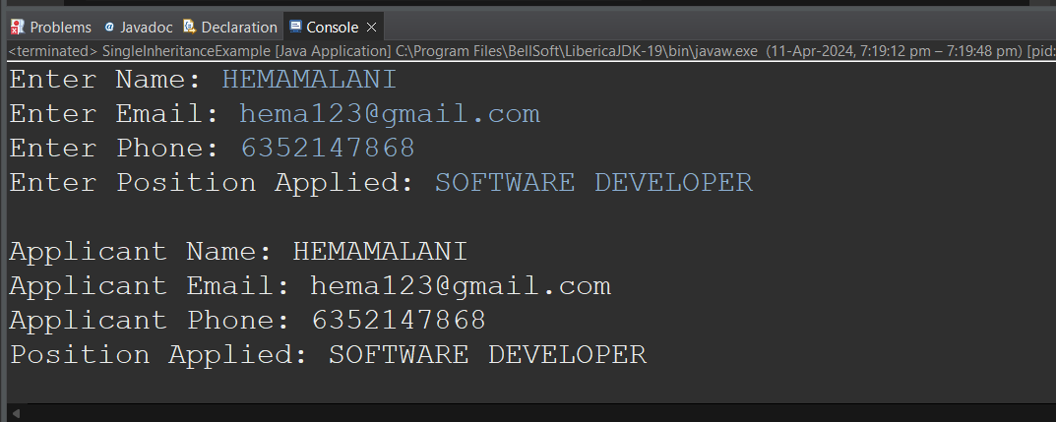

Multilevel Inheritance :

package JAVA_CONCEPTS;

import java.util.Scanner;

class ApplicationForm {

protected String name;

protected String email;

protected String phone;

public ApplicationForm(String name, String email, String phone) {

this.name = name;

this.email = email;

this.phone = phone;

}

public String getName() {

return name;

}

public String getEmail() {

return email;

}

public String getPhone() {

return phone;

}

public void setName(String name) {

this.name = name;

}

public void setEmail(String email) {

this.email = email;

}

public void setPhone(String phone) {

this.phone = phone;

}

}

class JobApplicationForm extends ApplicationForm {

private String position;

public JobApplicationForm(String name, String email, String phone, String position) {

super(name, email, phone);

this.position = position;

}

public String getPosition() {

return position;

}

public void setPosition(String position) {

this.position = position;

}

}

class InternshipApplicationForm extends JobApplicationForm {

private int durationMonths;

public InternshipApplicationForm(String name, String email, String phone, String position, int durationMonths) {

super(name, email, phone, position);

this.durationMonths = durationMonths;

}

public int getDurationMonths() {

return durationMonths;

}

public void setDurationMonths(int durationMonths) {

this.durationMonths = durationMonths;

}

}

public class MultilevelInheritanceExample {

public static void main(String[] args) {

Scanner scanner = new Scanner(System.in);

System.out.print("Enter Applicant Name: ");

String name = scanner.nextLine();

System.out.print("Enter Applicant Email: ");

String email = scanner.nextLine();

System.out.print("Enter Applicant Phone: ");

String phone = scanner.nextLine();

System.out.print("Enter Position Applied: ");

String position = scanner.nextLine();

System.out.print("Enter Internship Duration (in months): ");

int durationMonths = scanner.nextInt();

InternshipApplicationForm internForm = new InternshipApplicationForm(name, email, phone, position, durationMonths);

System.out.println("\nApplicant Name: " + internForm.getName());

System.out.println("Applicant Email: " + internForm.getEmail());

System.out.println("Applicant Phone: " + internForm.getPhone());

System.out.println("Position Applied: " + internForm.getPosition());

System.out.println("Internship Duration (months): " + internForm.getDurationMonths());

scanner.close();

}

}

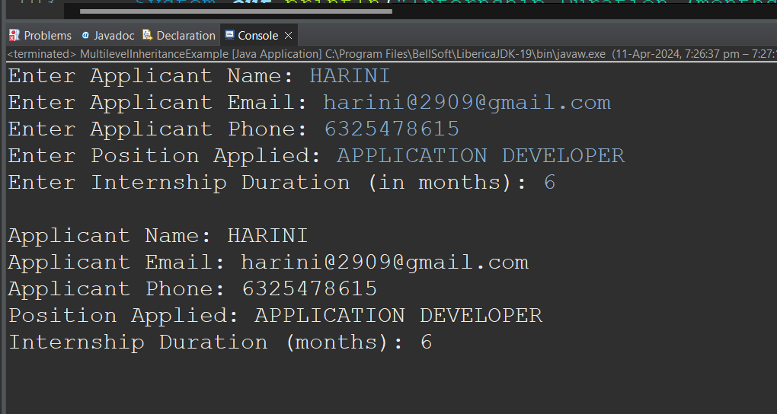

MUTLILEVEL INHERITANCE :

package JAVA_CONCEPTS;

import java.util.Scanner;

class ApplicationForm {

protected String name;

protected String email;

protected String phone;

public ApplicationForm(String name, String email, String phone) {

this.name = name;

this.email = email;

this.phone = phone;

}

public String getName() {

return name;

}

public String getEmail() {

return email;

}

public String getPhone() {

return phone;

}

public void setName(String name) {

this.name = name;

}

public void setEmail(String email) {

this.email = email;

}

public void setPhone(String phone) {

this.phone = phone;

}

}

interface Position {

void setPosition(String position);

String getPosition();

}

class JobApplicationForm extends ApplicationForm implements Position {

private String position;

public JobApplicationForm(String name, String email, String phone, String position) {

super(name, email, phone);

this.position = position;

}

public String getPosition() {

return position;

}

public void setPosition(String position) {

this.position = position;

}

}

class InternshipApplicationForm extends JobApplicationForm {

private int durationMonths;

public InternshipApplicationForm(String name, String email, String phone, String position, int durationMonths) {

super(name, email, phone, position);

this.durationMonths = durationMonths;

}

public int getDurationMonths() {

return durationMonths;

}

public void setDurationMonths(int durationMonths) {

this.durationMonths = durationMonths;

}

}

public class HybridInheritanceExample {

public static void main(String[] args) {

Scanner scanner = new Scanner(System.in);

System.out.print("Enter Applicant Name: ");

String name = scanner.nextLine();

System.out.print("Enter Applicant Email: ");

String email = scanner.nextLine();

System.out.print("Enter Applicant Phone: ");

String phone = scanner.nextLine();

System.out.print("Enter Position Applied: ");

String position = scanner.nextLine();

System.out.print("Enter Internship Duration (in months): ");

int durationMonths = scanner.nextInt();

InternshipApplicationForm internForm = new InternshipApplicationForm(name, email, phone, position, durationMonths);

System.out.println("\nApplicant Name: " + internForm.getName());

System.out.println("Applicant Email: " + internForm.getEmail());

System.out.println("Applicant Phone: " + internForm.getPhone());

System.out.println("Position Applied: " + internForm.getPosition());

System.out.println("Internship Duration (months): " + internForm.getDurationMonths());

scanner.close();

}

}

OUTPUT :

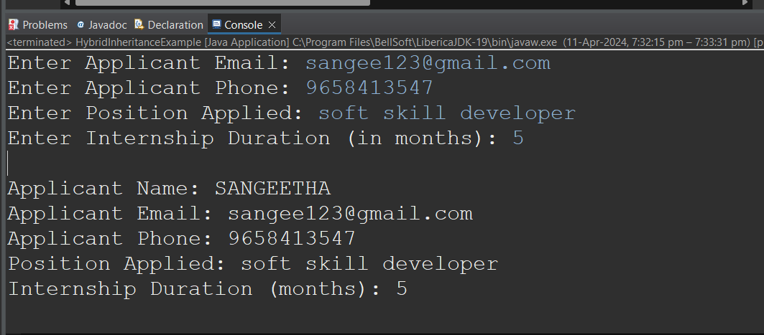

MULTIPLE INHERITANCE:

package JAVA_CONCEPTS;

import java.util.Scanner;

interface BasicInformation {

void setName(String name);

String getName();

void setEmail(String email);

String getEmail();

void setPhone(String phone);

String getPhone();

}

interface Position {

void setPosition(String position);

String getPosition();

}

class ApplicationForm implements BasicInformation {

protected String name;

protected String email;

protected String phone;

public String getName() {

return name;

}

public void setName(String name) {

this.name = name;

}

@Override

public String getEmail() {

return email;

}

@Override

public void setEmail(String email) {

this.email = email;

}

public String getPhone() {

return phone;

}

public void setPhone(String phone) {

this.phone = phone;

}

}

class JobApplicationForm extends ApplicationForm implements Position {

private String position;

public String getPosition() {

return position;

}

public void setPosition(String position) {

this.position = position;

}

}

class InternshipApplicationForm extends JobApplicationForm {

private int durationMonths;

public int getDurationMonths() {

return durationMonths;

}

public void setDurationMonths(int durationMonths) {

this.durationMonths = durationMonths;

}

}

public class MultipleInheritanceExample {

public static void main(String[] args) {

Scanner scanner = new Scanner(System.in);

System.out.print("Enter Applicant Name: ");

String name = scanner.nextLine();

System.out.print("Enter Applicant Email: ");

String email = scanner.nextLine();

System.out.print("Enter Applicant Phone: ");

String phone = scanner.nextLine();

System.out.print("Enter Position Applied: ");

String position = scanner.nextLine();

System.out.print("Enter Internship Duration (in months): ");

int durationMonths = scanner.nextInt();

InternshipApplicationForm internForm = new InternshipApplicationForm();

internForm.setName(name);

internForm.setEmail(email);

internForm.setPhone(phone);

internForm.setPosition(position);

internForm.setDurationMonths(durationMonths);

System.out.println("\nApplicant Name: " + internForm.getName());

System.out.println("Applicant Email: " + internForm.getEmail());

System.out.println("Applicant Phone: " + internForm.getPhone());

System.out.println("Position Applied: " + internForm.getPosition());

System.out.println("Internship Duration (months): " + internForm.getDurationMonths());

scanner.close();

}

}

OUTPUT :

